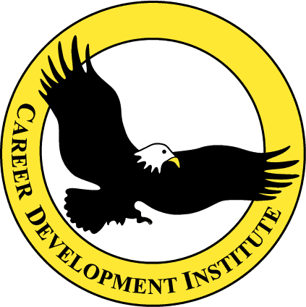

ICS 200 Certification for County Animal Rescue Teams, Animal Control Officers and Cruelty Investigators

Who Should Attend: All CART Members, Municipal Animal Control Officers, Municipal Animal Cruelty Investigators, Public Health Emergency Responders. Shelter Management, Dept of Agriculture Personnel, Dept of Health Personnel

This Unique 16 hour Course, taught by experienced first responders, is designed to address the specific responsibilities and skills of emergency responders providing for the care and control of animals in a disaster or emergency situations.

Course content includes:

• Leadership and Management: Participants will describe chain of command and formal communication relationships, identify common leadership responsibilities, describe span of control and modular development and describe the use of position titles.

• Delegation of Authority and Management by Objectives: You will identify scope of authority and the process by which authority is delegated. Management by objectives will be described and explained.

• Functional Areas and Positions: Everyone will identify the ICS tools to manage an incident, demonstrate the function of organizational positions within ICS and demonstrate the use of an ICS 201 form.

• Briefings: Participants will learn how to give an Operational Briefing and describe the components of field, staff and section briefings/meetings.

• Organizational Flexibility: Learn how the modular organization expands and contracts, complete a complexity analysis given a specific scenario, define the five types of incidents, and describe the importance of preparedness plans and agreements.

• Transfer of Command: You will list the essential elements of information involved in transfer of command and describe a transfer of command process.

To register contact CAREER DEVELOPMENT INSTITUTE at www.cditraining.org

or call 1-800-244 6921.

